EXPERIMENT 6: - Create a simple cloud software application for Payroll Processing System using any Cloud Service Provider to demonstrate SaaS include the necessary fields such as Name of the employee, experience in present org, over all experience, basic pay, HRA, DA, TA, net pay, gross pay etc.

Step 1: - Go to ZOHO.com

Step 2: - Create and account and log into the account

Step 3: - Create an application

Step 4: - Create login page

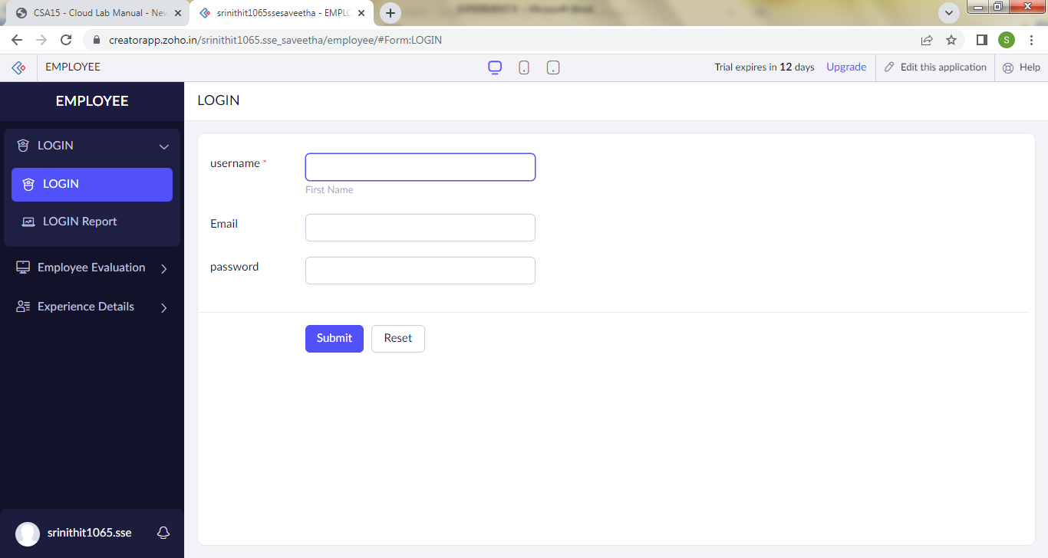

Step 5: - Create a form for employee details

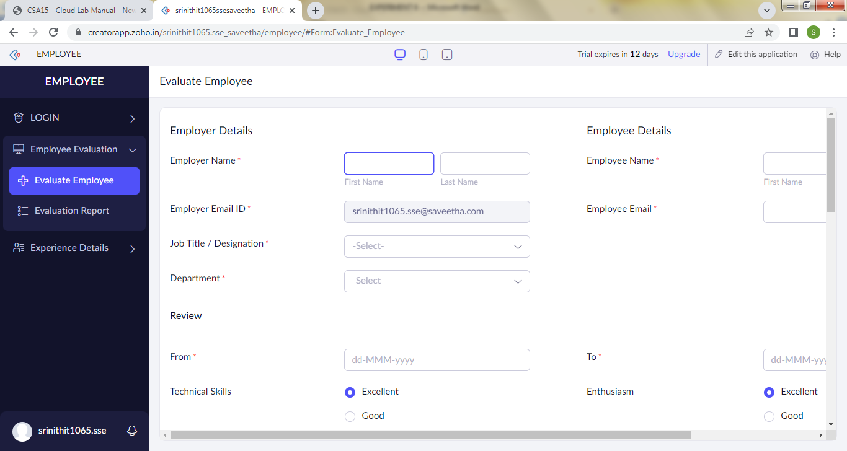

Step 6: - Create a form to get allowances details

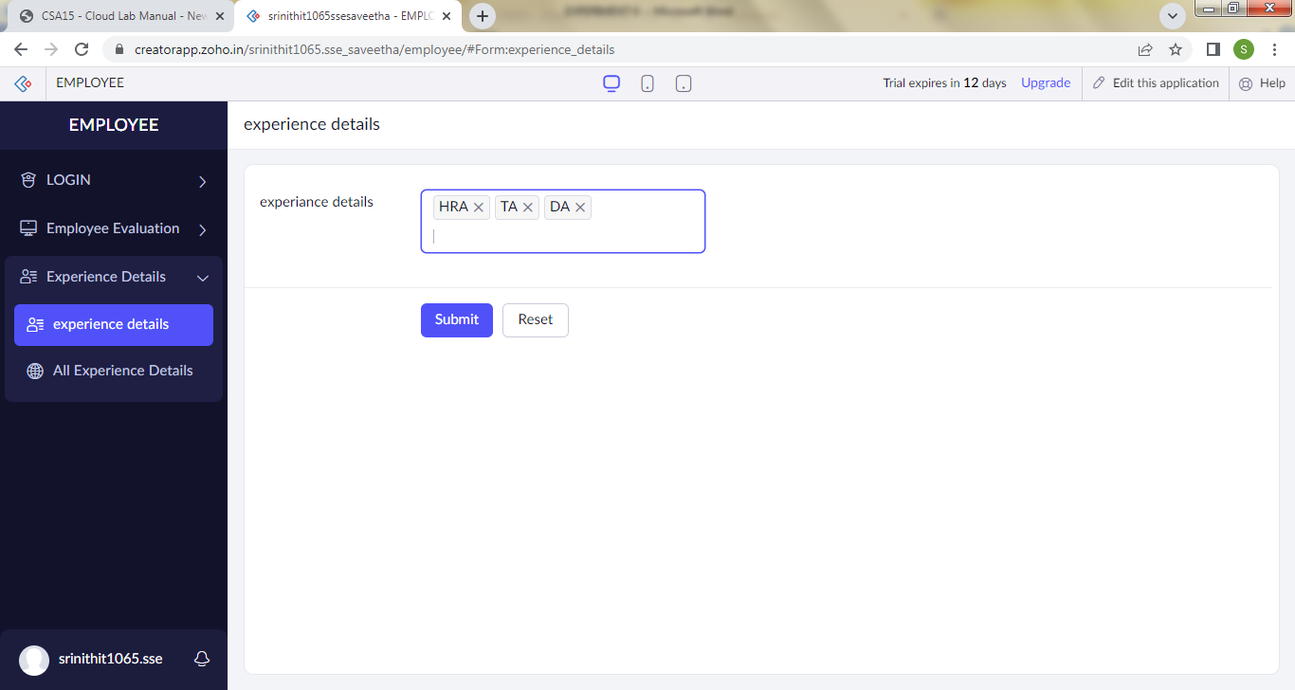

Step 8: - Click on the access development live to see the output

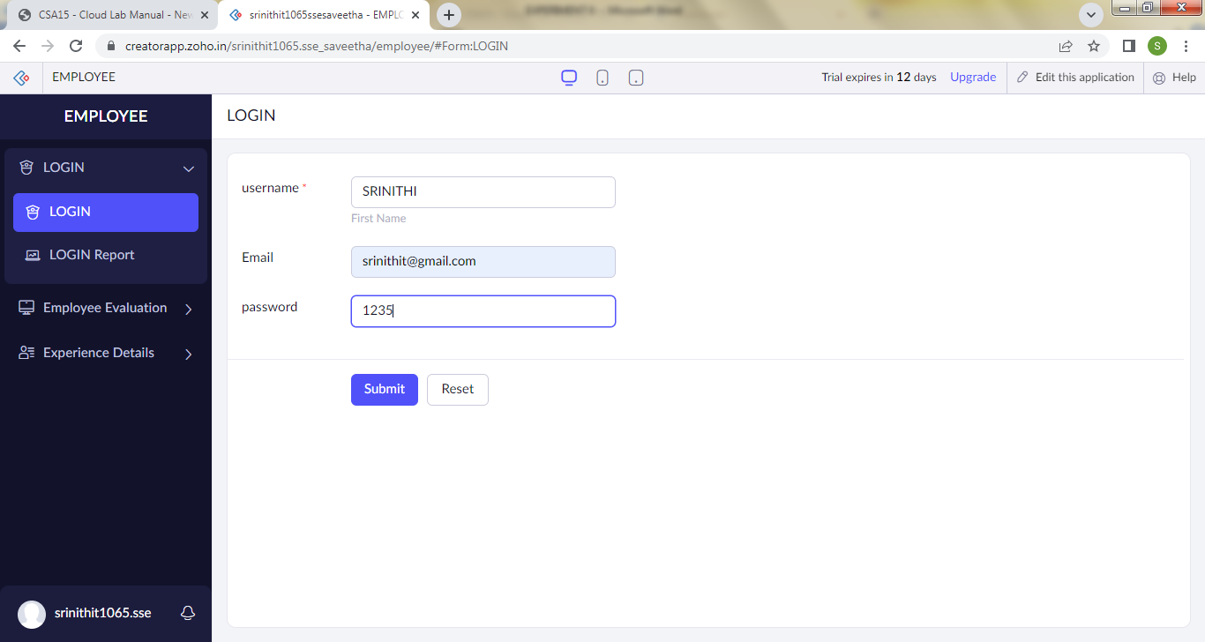

Step 9: - Click on the report to see the saved data

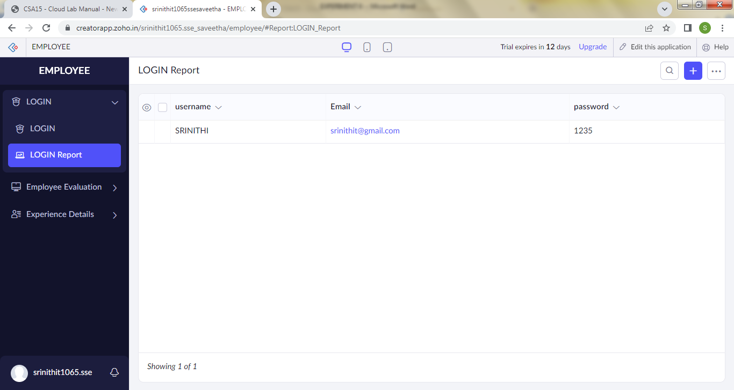

Step 10: - Click on the mobile icon to see the output in mobile format

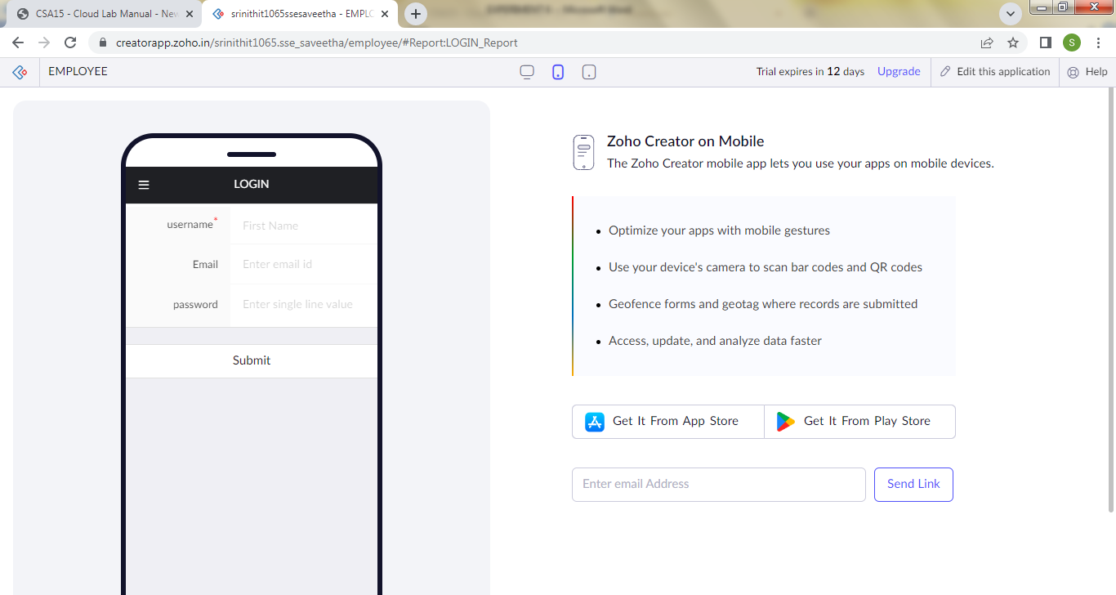

Step 11: - Click on the tablet icon to see the output in tablet format

